How LLM’s Remember
A parameterized mathematical function is a function whose behavior depends on one or more parameters along with input.
A parameterized function:
$$f\left(x ; a\right)=ax^{2}$$
Here:
- x = input
- a = parameter that controls the function's behavior
We get the values of those parameters from the data.
We can represent an LLM as a mathematical function:
$$y=f\left(x ; θ\right)$$
Explanation:
- $f$= the complex function representing the computations performed by the LLM. We do not need to worry about its internal complexity here.
- $θ$= the billions of parameters learned by the LLM during training.
- $x$= the input, such as input tokens or a prompt.
- $y$= the output, such as the response/output tokens.
- The values of $θ$are learned from training data.
The output $y$depends on both the parameters $θ$and the input $x$:
$$y=f\left(x ; θ\right)$$
Explanation:
- $θ$represents the billions of parameters of the LLM.
- During inference, $θ$remains fixed after training.
- $x$represents the input tokens or prompt, which can change for every request.
- Therefore, changing $x$can produce a different output $y$, while the learned parameters $θ$remain the same.
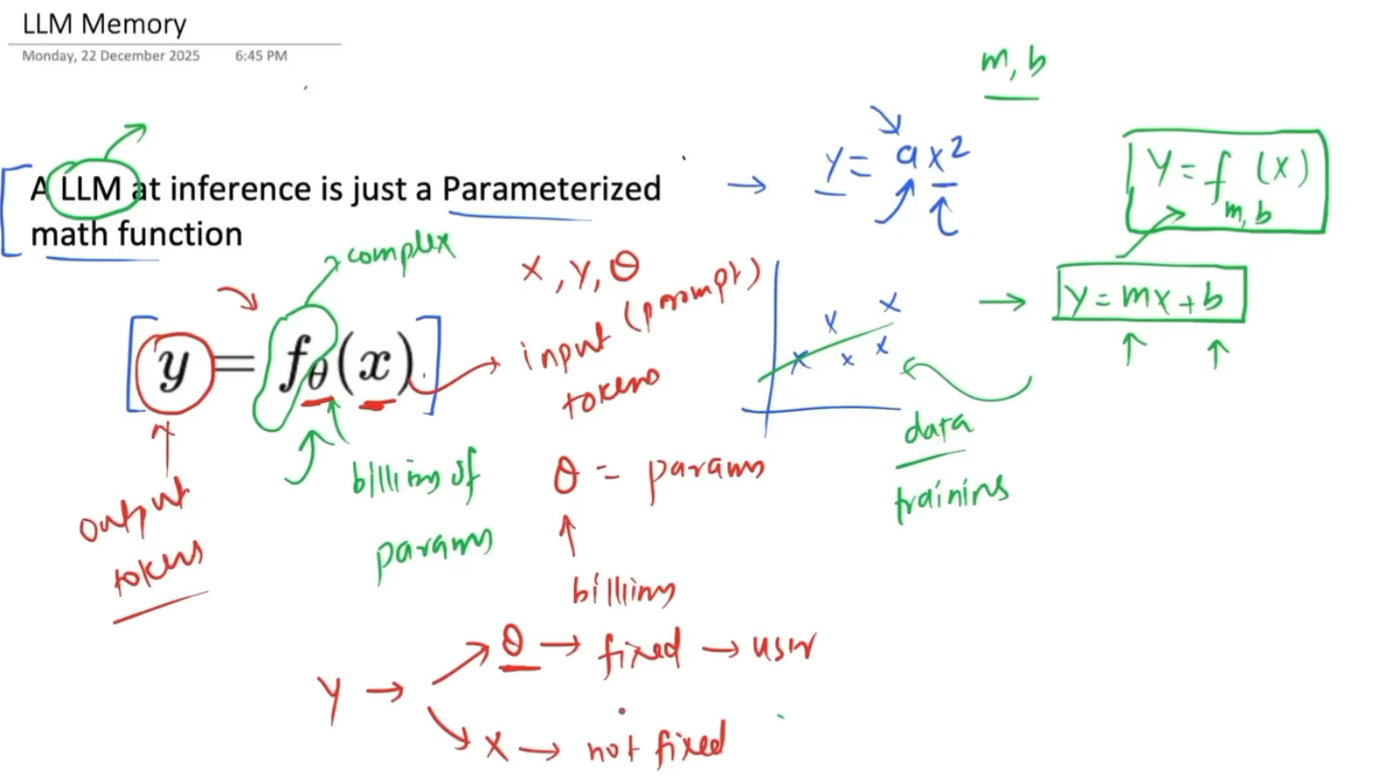
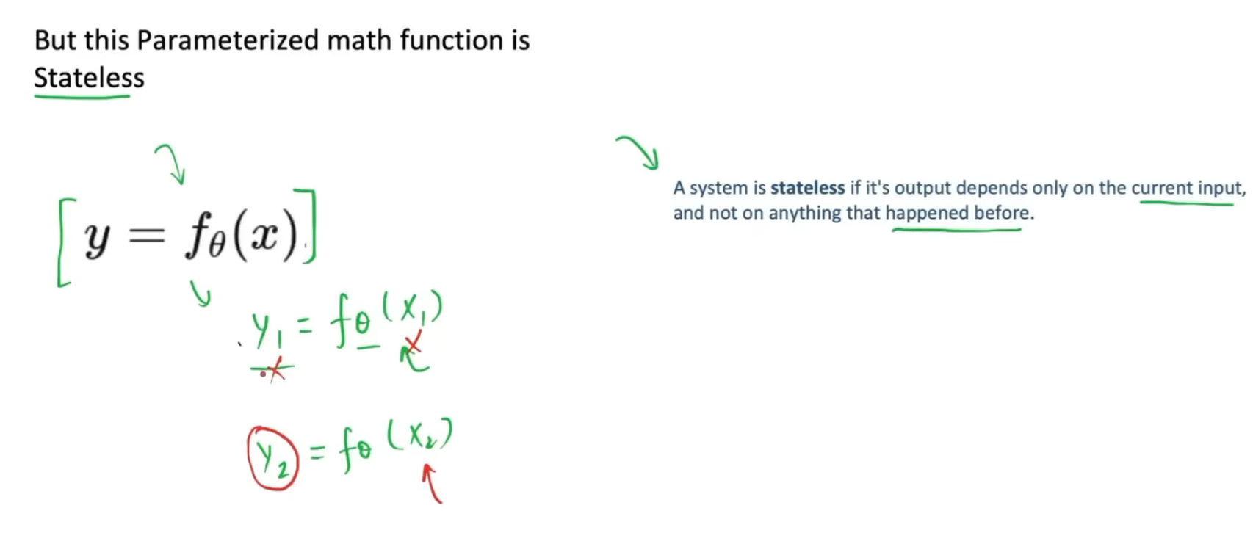

An LLM itself does not have persistent memory of previous interactions. Since applications often need memory, we externally add a memory system to the LLM.
The ability to provide a large amount of information to an LLM through its context window as input tokens forms the basis for implementing memory.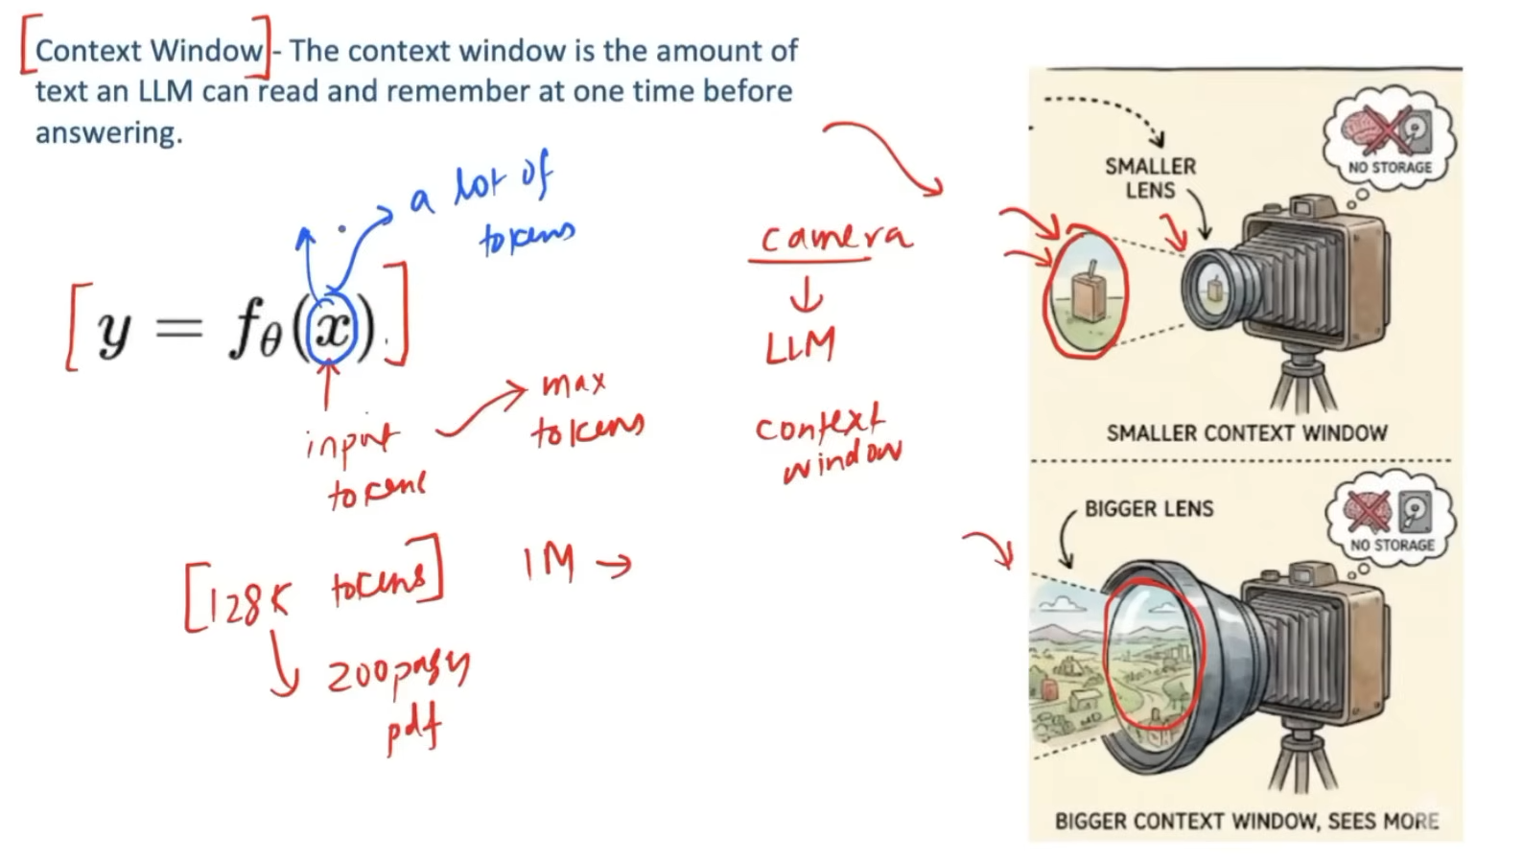
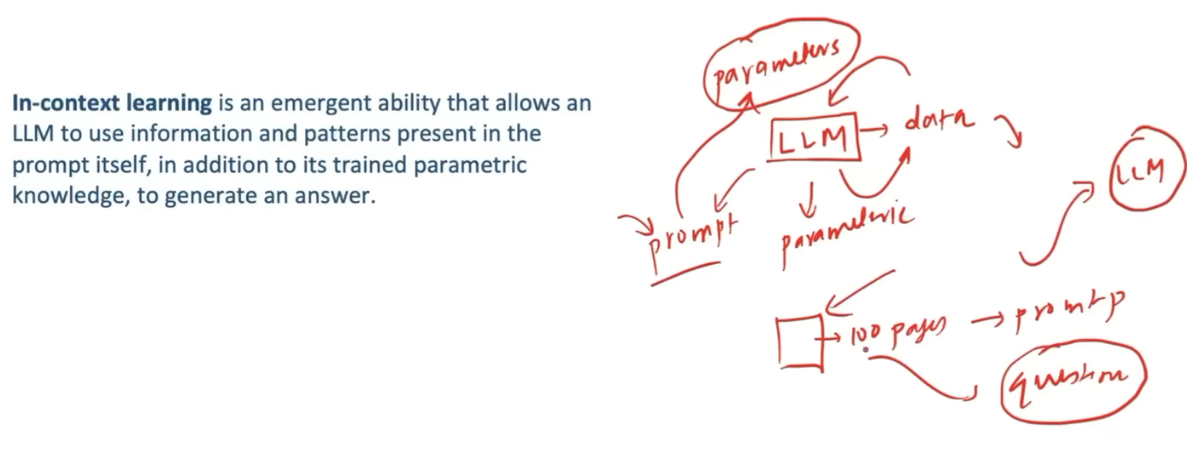
Basically, what we do is send the previous conversation along with the new query as input to the LLM. This allows the LLM to use the previous conversation as context when generating its response.
Explanation:
- When we give a new query, we also provide the previous conversation in the context window.
- If the required information is not available in the LLM's parametric knowledge, it can use the information provided in the current context to answer the query.
- Using information provided in the input context to help generate the answer is called in-context learning.
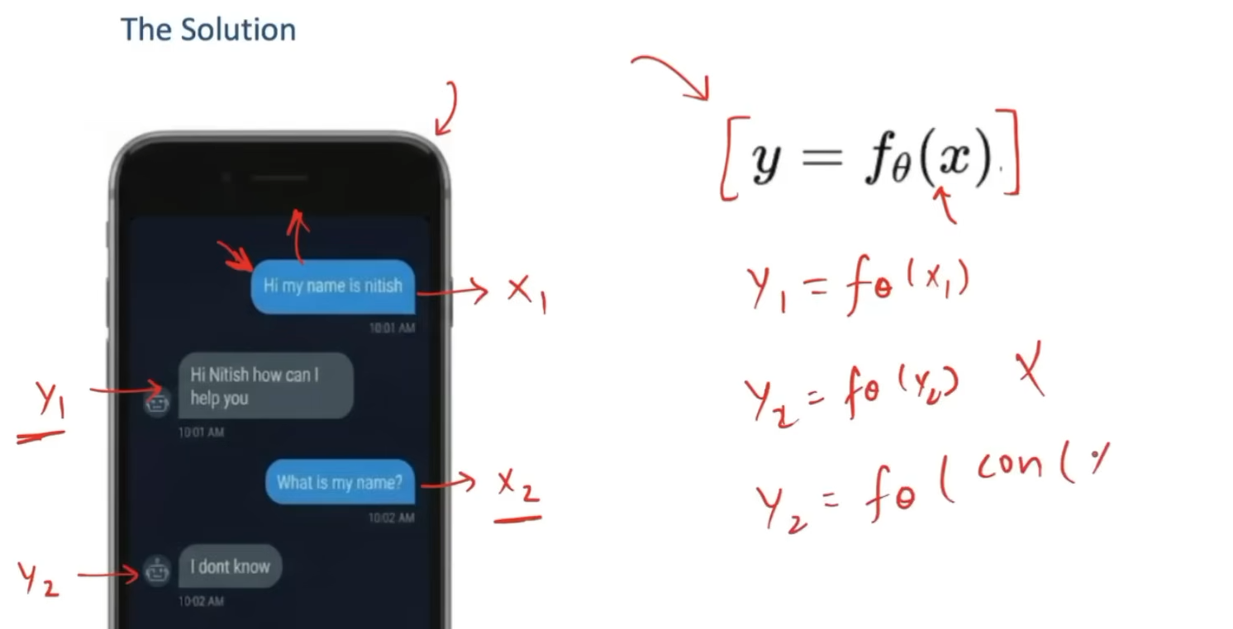
Example:- We create a list called messages to maintain the conversation history and provide it to the LLM as context.
Explanation:
- We create a list called messages.
- We send the current message to the LLM and get its output.
- We append that output to the messages list.
- The updated messages list, containing the previous conversation, is then sent to the LLM along with the next user query.

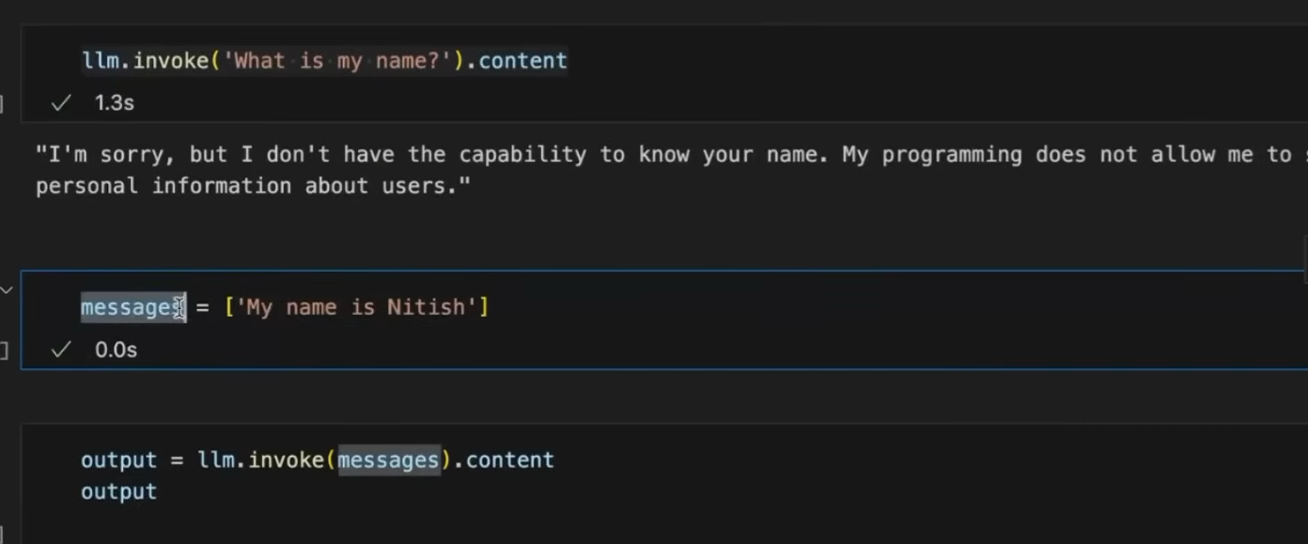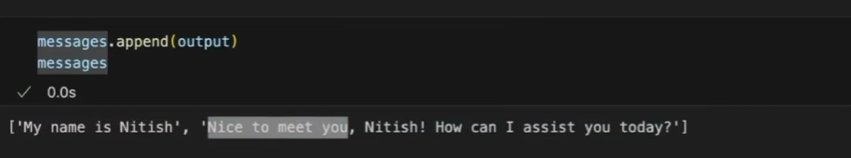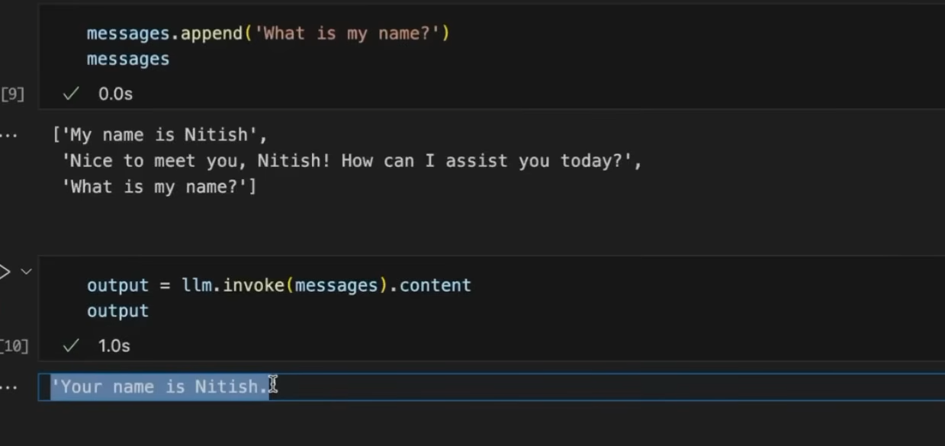
Once we restart the application and directly ask a question about previous information, the LLM loses the previous context needed to answer it. Hence, this is called short-term memory.

Each chat or thread has its own short-term memory. The messages list stores the context for that thread and is reset when we start a new thread.
Explanation:
- Each new chat/thread starts with an empty messages list.
- As we interact within that thread, the conversation context is added to the messages list.
- When we move to a new thread, the previous thread's context is not carried over; the new thread starts with its own context.
- This is why short-term memory is also called thread-scope memory: it exists only within a particular thread and is reset for a new thread.
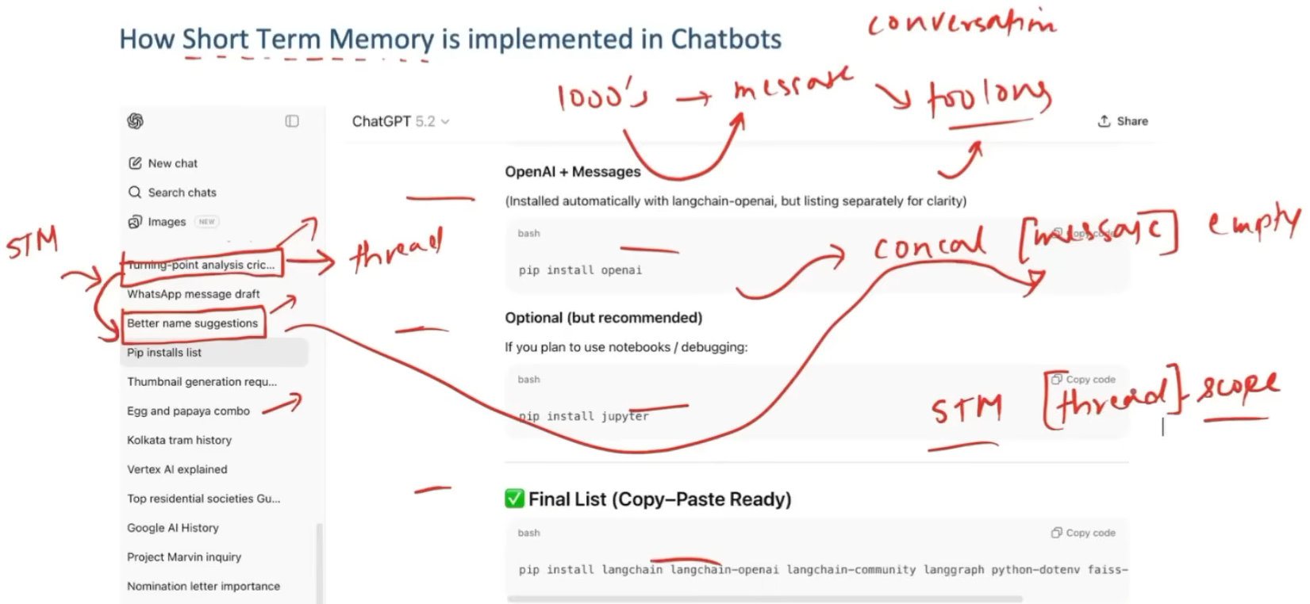
If we move from one chat/thread to another and only have short-term memory, the previous chat's context would be lost because the messages list now contains the context of the second chat. Therefore, we need persistence to store the messages externally, such as in a database.
Explanation:
- Suppose we have Chat 1 with its conversation stored in the messages list.
- When we move to Chat 2, the messages list is updated with the context of Chat 2.
- If we only use short-term memory, the context of Chat 1 is no longer available in memory.
- To prevent this, we store the messages of each thread in a database.
- Each chat/thread is given a unique thread_id.
- The thread_id is used to identify a particular chat and retrieve its stored context.
- If we later return to that chat, we use its thread_id to retrieve the previous messages/context and continue the conversation.
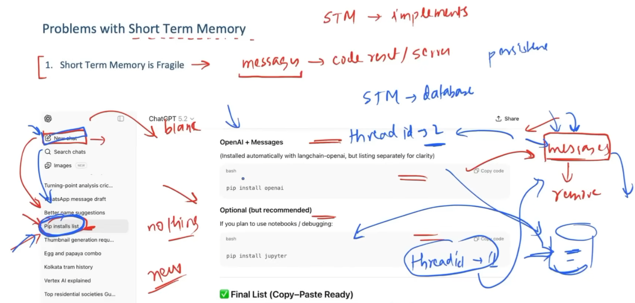

A chat can become very large with all the past context, so instead of sending the entire conversation every time, we can send the last $N$messages, a summary of the remaining older messages, and the current query.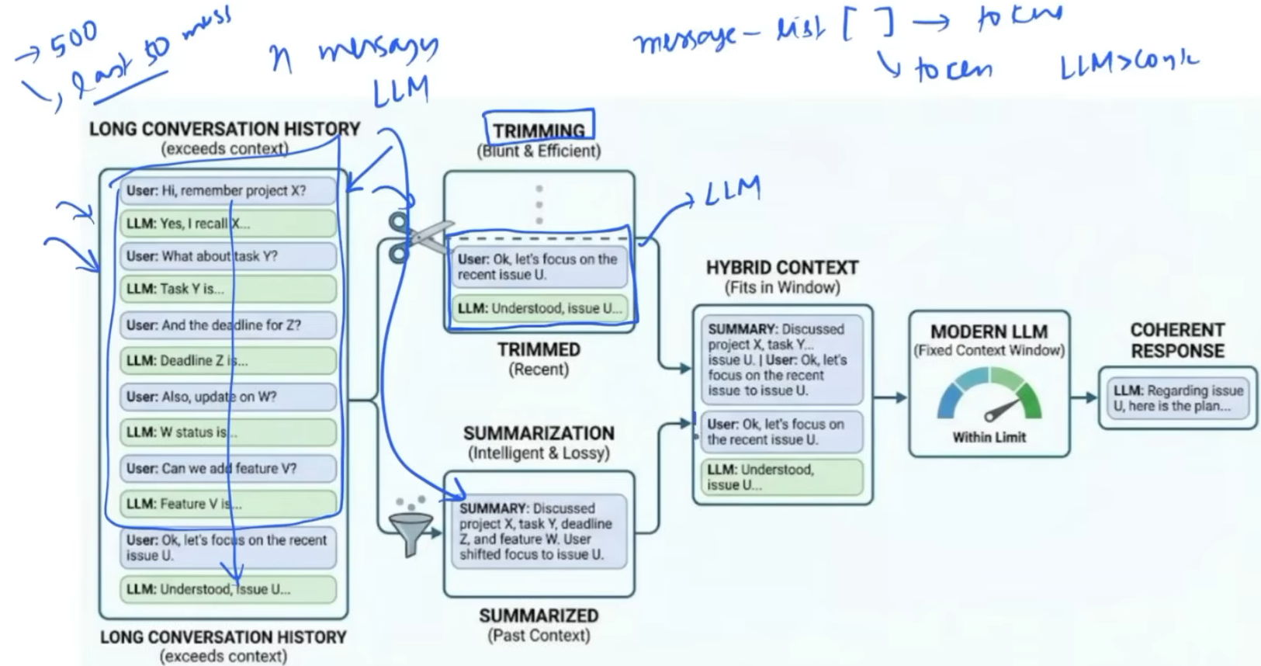
With only short-term memory, we cannot effectively provide personalization across multiple chats, such as in a personal assistant that should remember the user's preferences.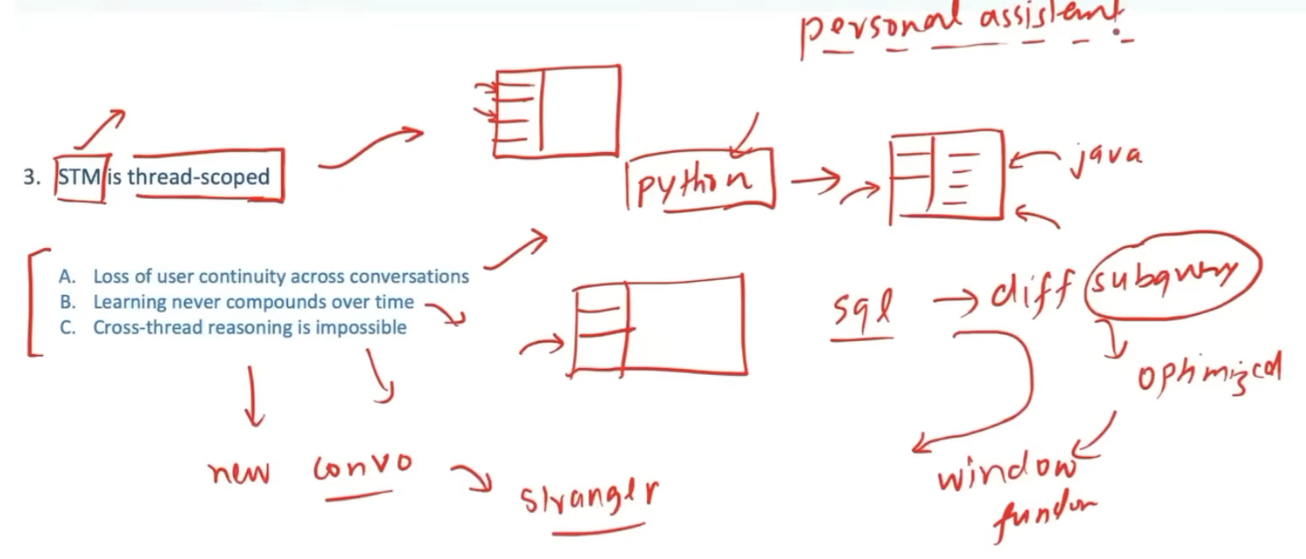
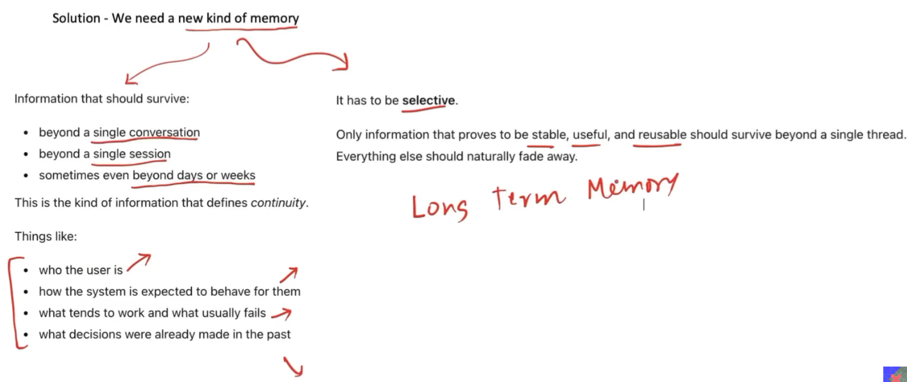
Semantic Memory — stores facts, knowledge, and general information.
- Example: “The user knows Java and Python.”
Episodic Memory — stores specific past events or experiences.
- Example: “The user previously worked on a deepfake detection project.”
Procedural Memory — stores information about how to perform tasks or procedures.
- Example: “When building this application, first retrieve documents, then generate the response.”
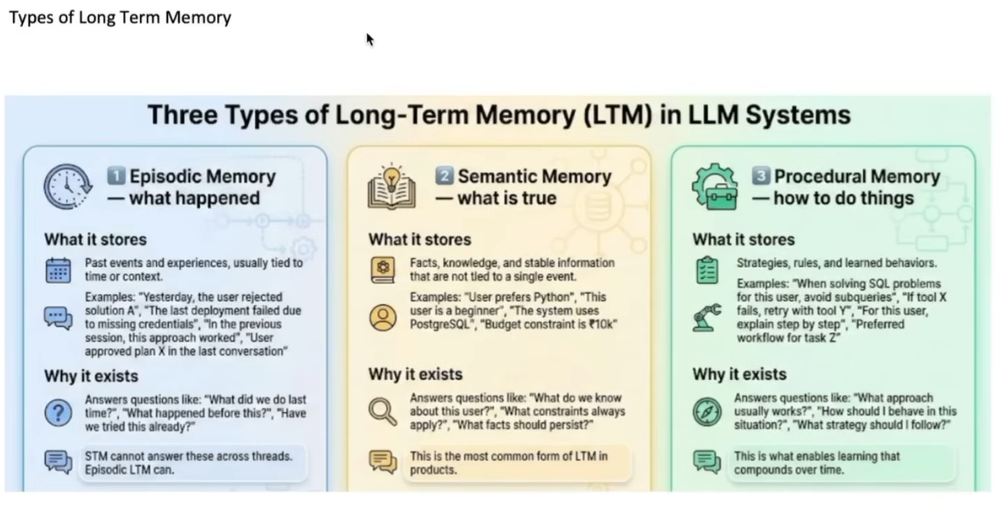
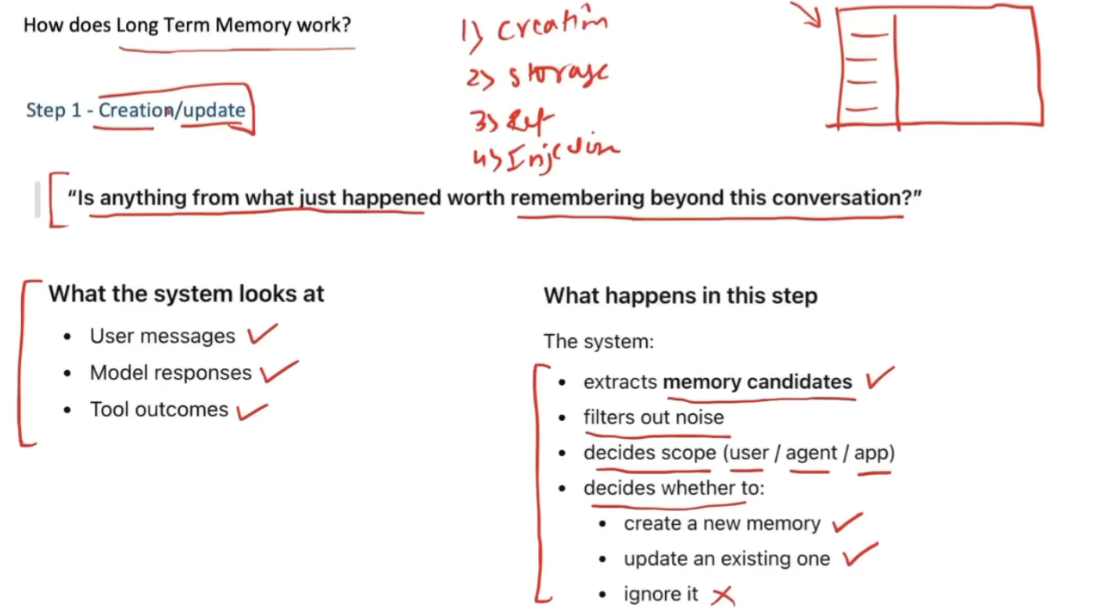
We store memory in different ways depending on the type of memory/data we are storing.
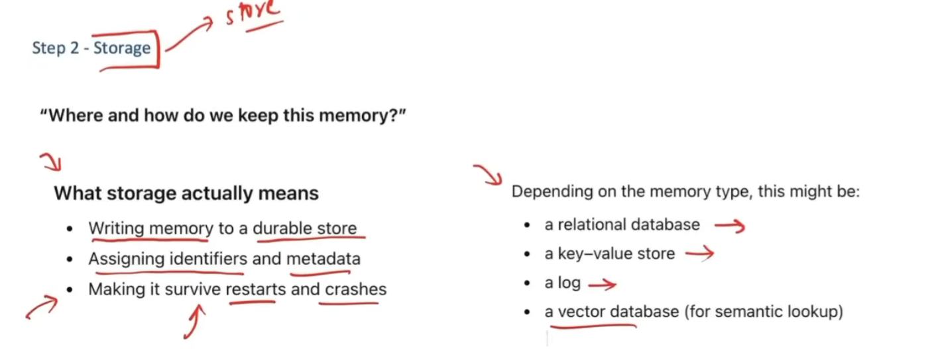

We do not bring everything from memory into the context. Instead, we retrieve only the specific memories needed to answer the current question.
Explanation:
- Memory may contain a large amount of information.
- Bringing all of it into the context window would be inefficient and could exceed the context limit.
- Therefore, we retrieve only the relevant memories for the current query.
- Hence, memory retrieval is selective, not exhaustiv
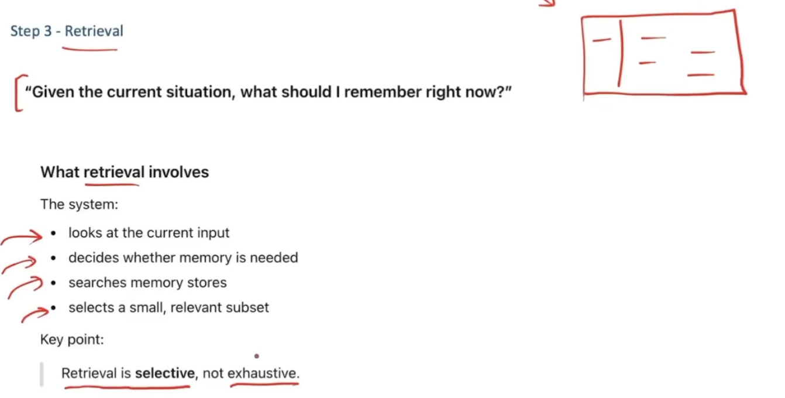
We never directly let the LLM interact with long-term memory. Instead, a retriever retrieves the relevant information from long-term memory and adds it to the short-term memory or conversation buffer.
Explanation:
- Long-term memory contains a large amount of stored information.
- The retriever selectively retrieves the relevant context from long-term memory.
- This retrieved context becomes part of the short-term memory/conversation buffer.
- The short-term memory + retrieved context + current query are then provided to the LLM.
- The LLM generates the response using this provided context.
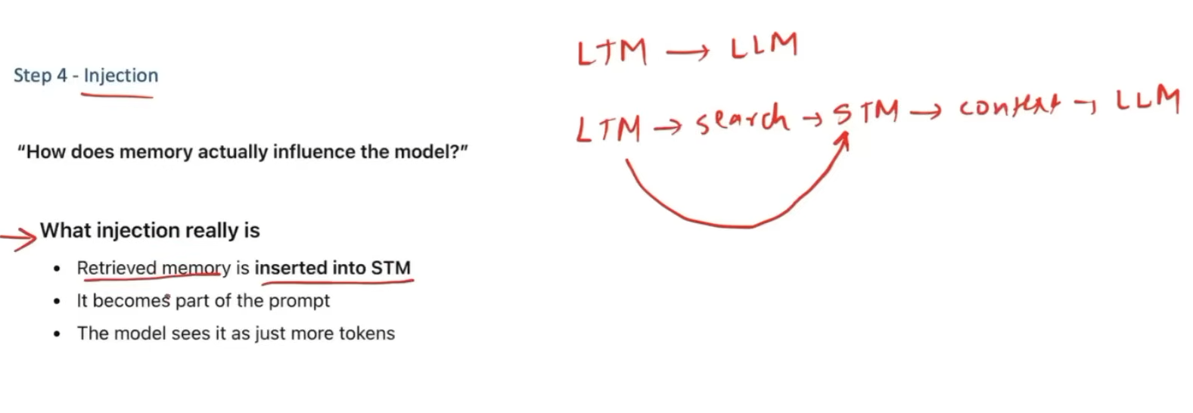

There are libraries and applications that help us manage memory for LLM-based applications. They act as a memory layer between the application and the underlying storage.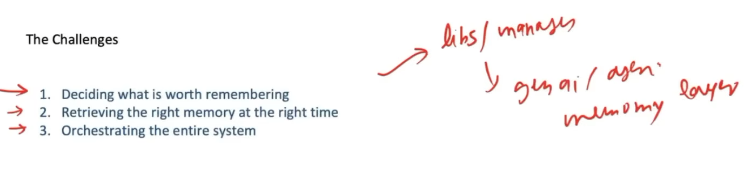
There are libraries and applications that help us implement and manage memory for LLM applications.
Explanation:
- Libraries such as LangMem help developers build memory functionality into LLM applications.
- There are also dedicated memory applications/services such as Mem0 and Supermemory that provide memory-related capabilities.
- These tools can act as a memory layer for storing and retrieving relevant information.
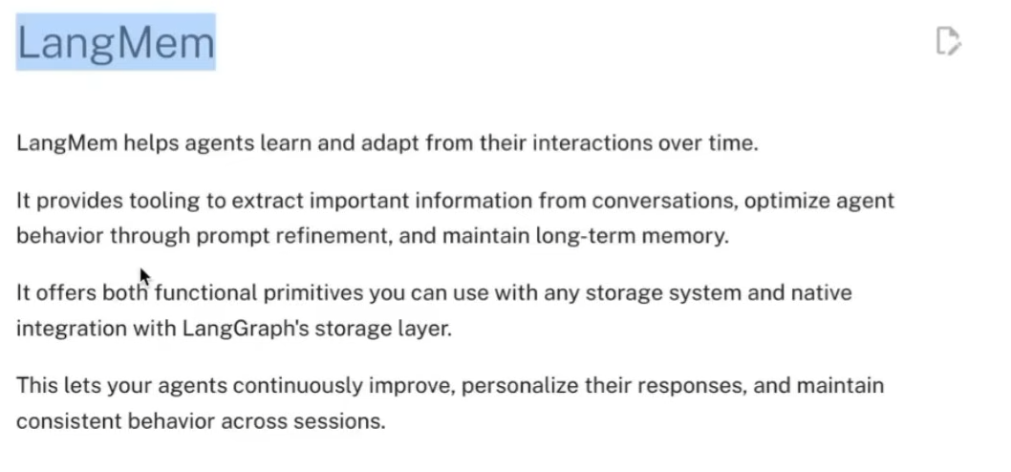


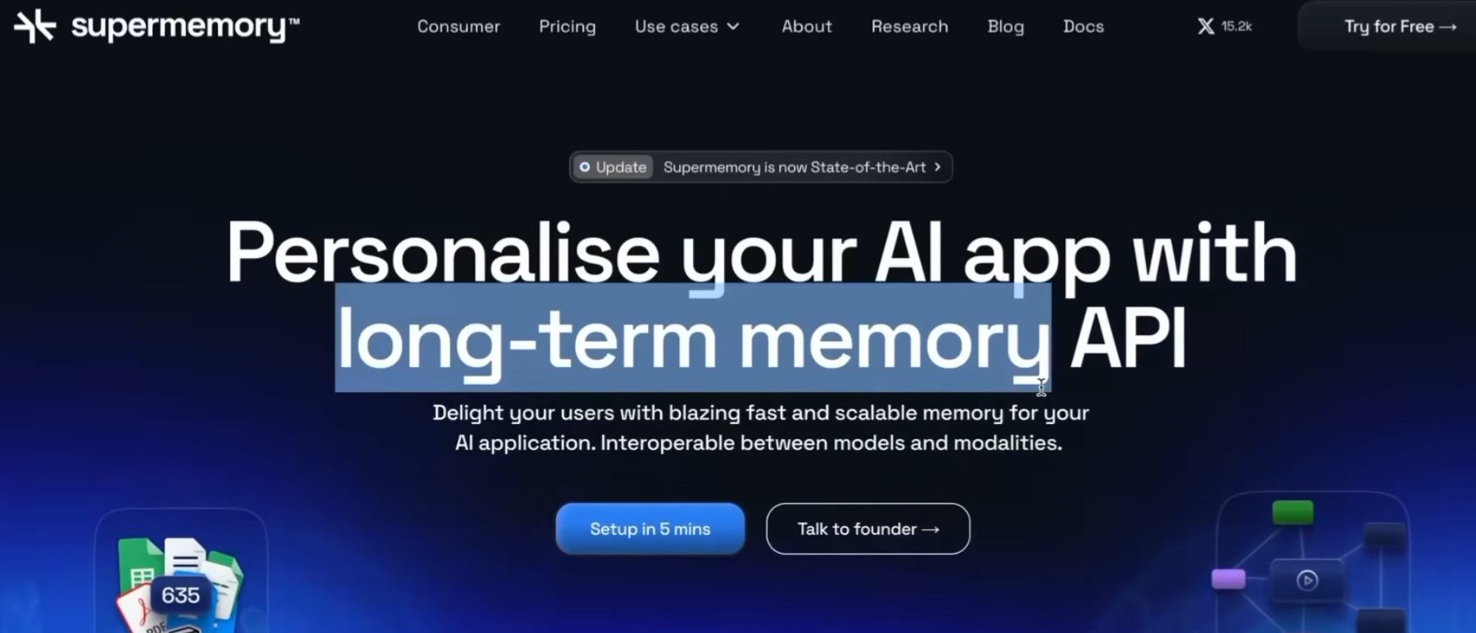
There are also attempts to create generative systems with their own memory, allowing them to store and use long-term memory.
Explanation:
- These systems aim to have memory built directly into the generative system.
- This allows the system to store long-term memories and potentially use them in future interactions.
- This is different from simply adding an external memory layer to a standard LLM.
